AWS MANAGEMENT SYSTEM

1] Amazon RDS ---> Create Database

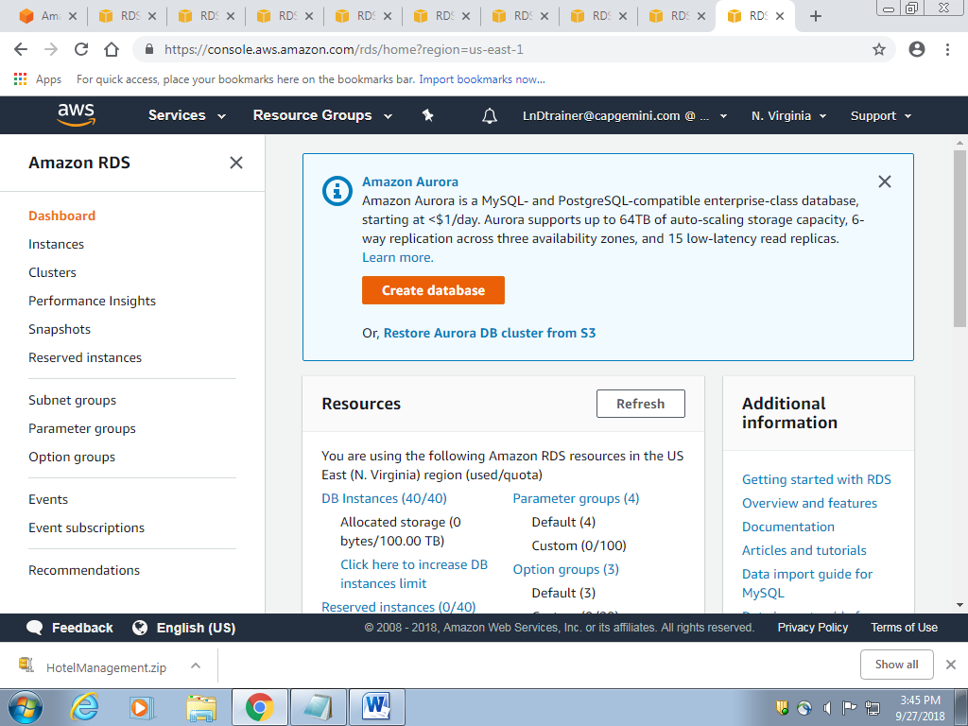

2] Select Engine ---> MYSQL

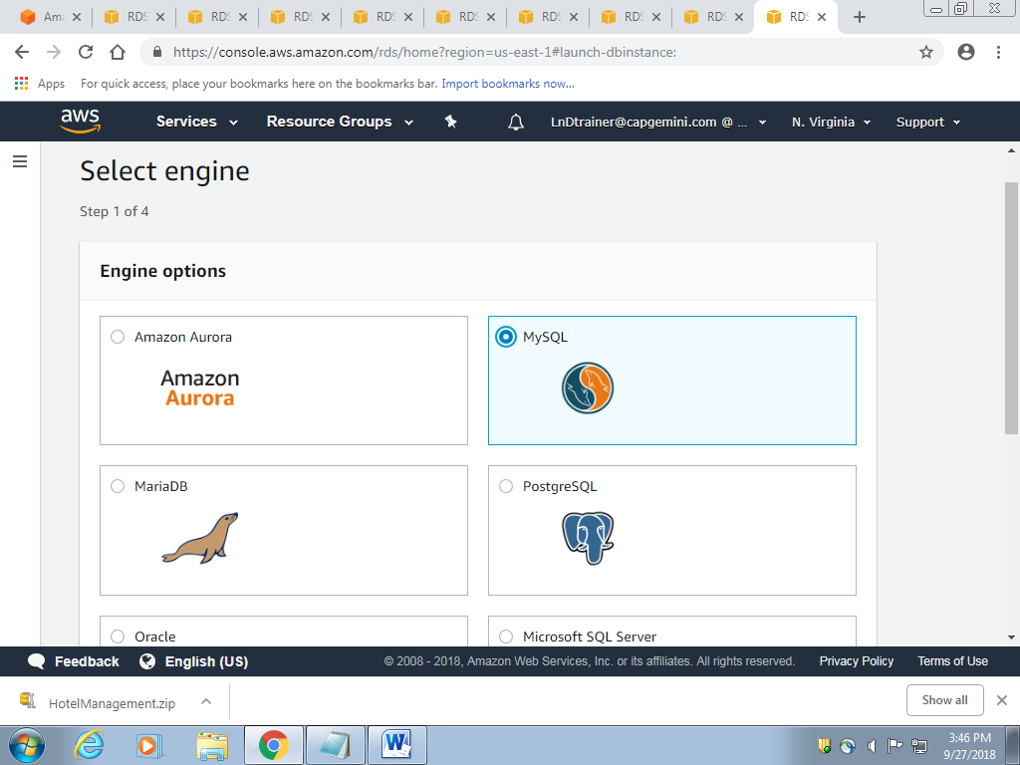

3] Choose UseCase ---> Amazon Aurora

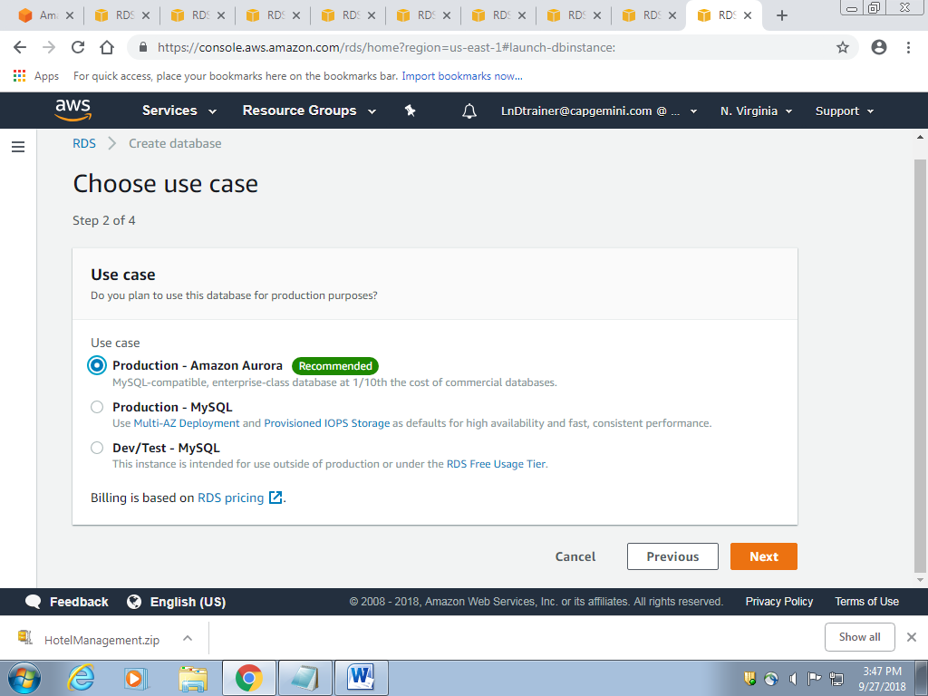

4] Specify DB Details --> Settings --->Fill details as shown

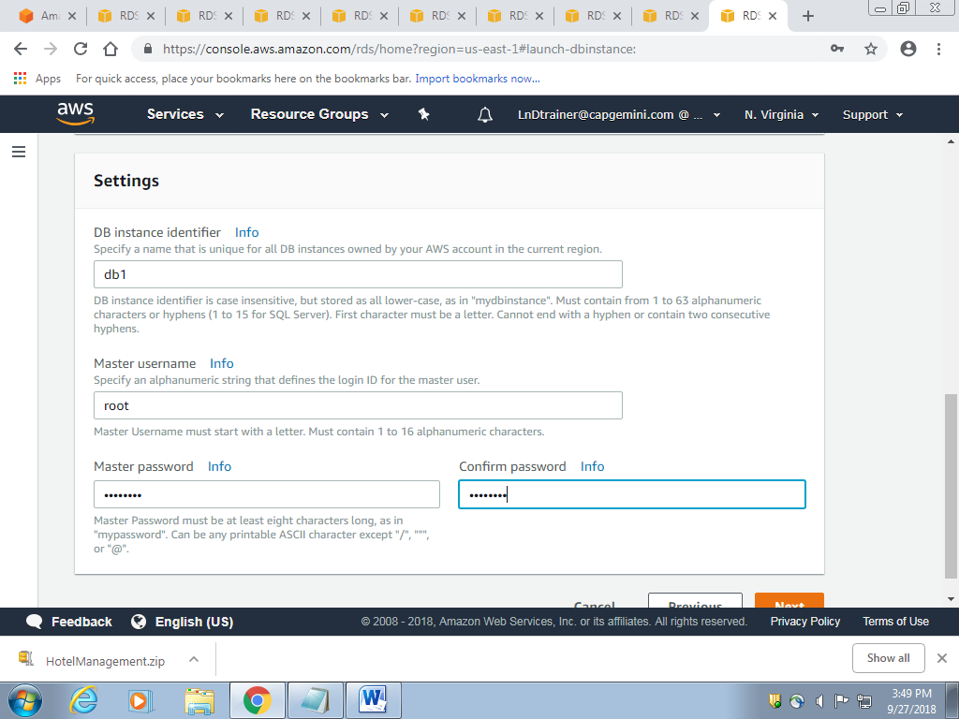

5] Configure advanced settings --->Network settings

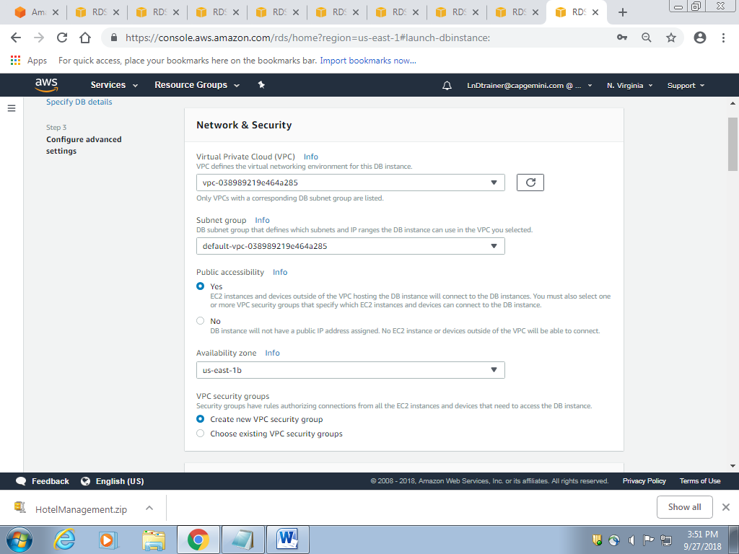

6] Configure advanced settings ---> Database options

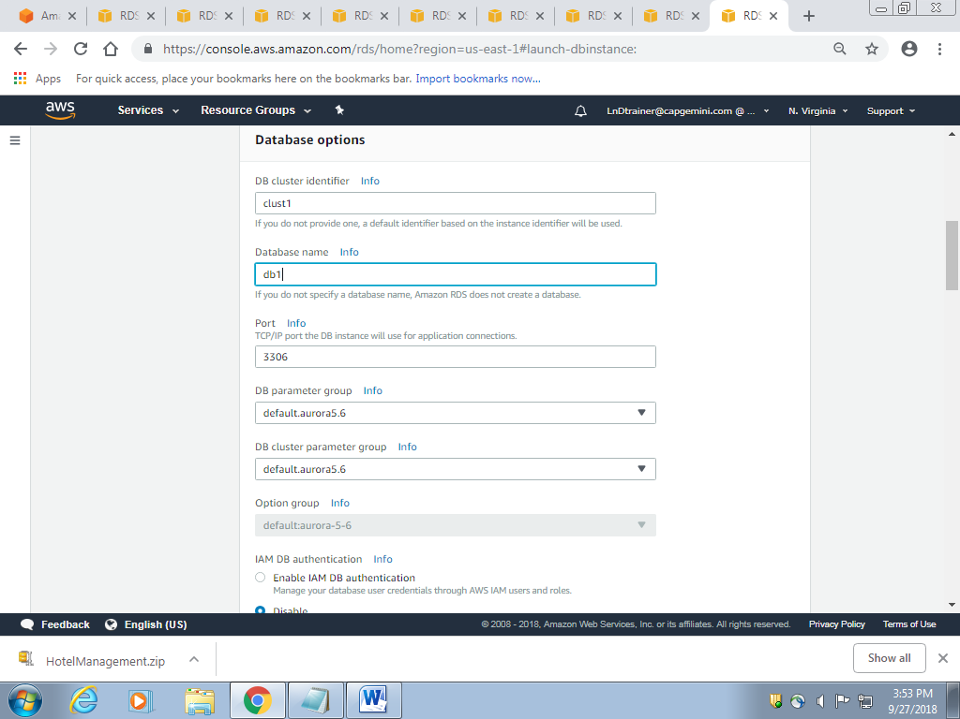

7] Configure advanced settings --->Encryption-->Disable Encryption

8] Configure advanced settings --->Monitoring-->Disable Enhanced Monitoring

9] Configure advanced settings --->Performance insights-->Disable

Select all log Exports

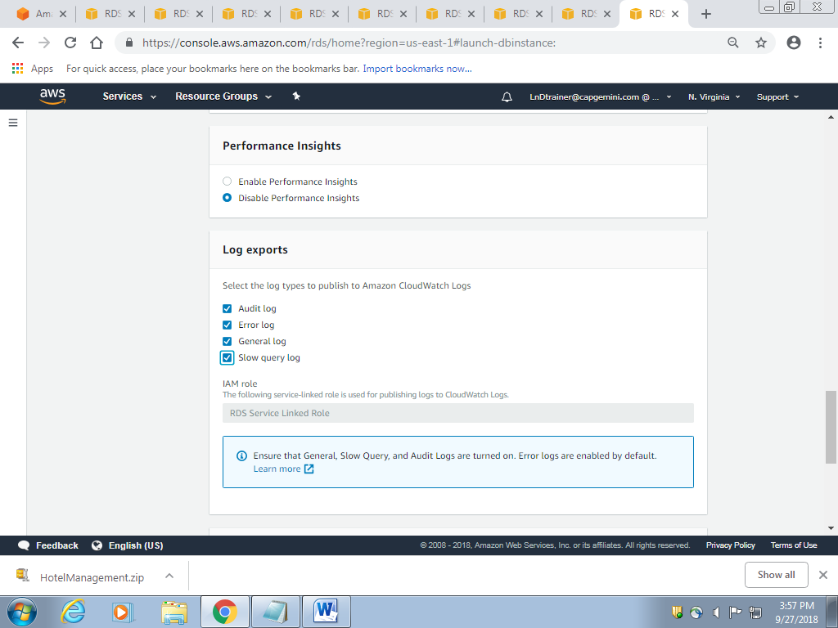

10] Configure advanced settings --->Maintenance -->Disable auto minor version upgrade

11] Click create database

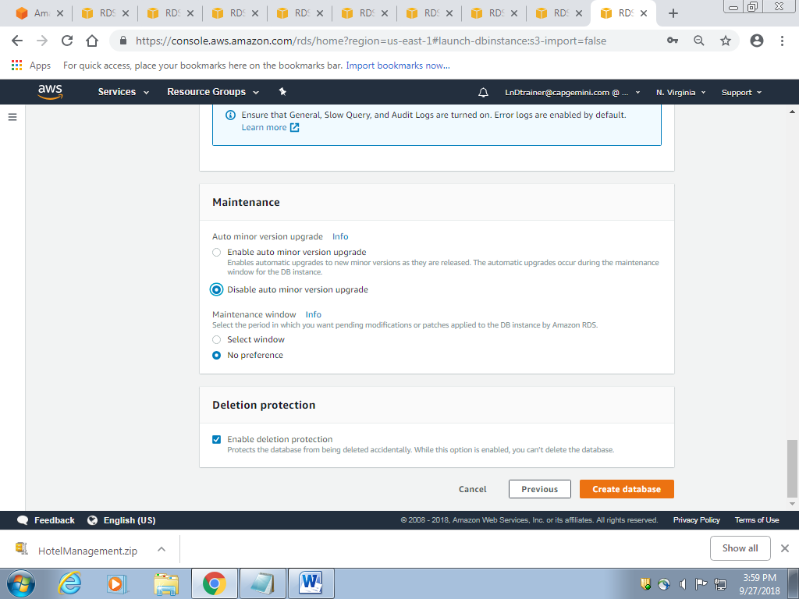

12] Check instance status

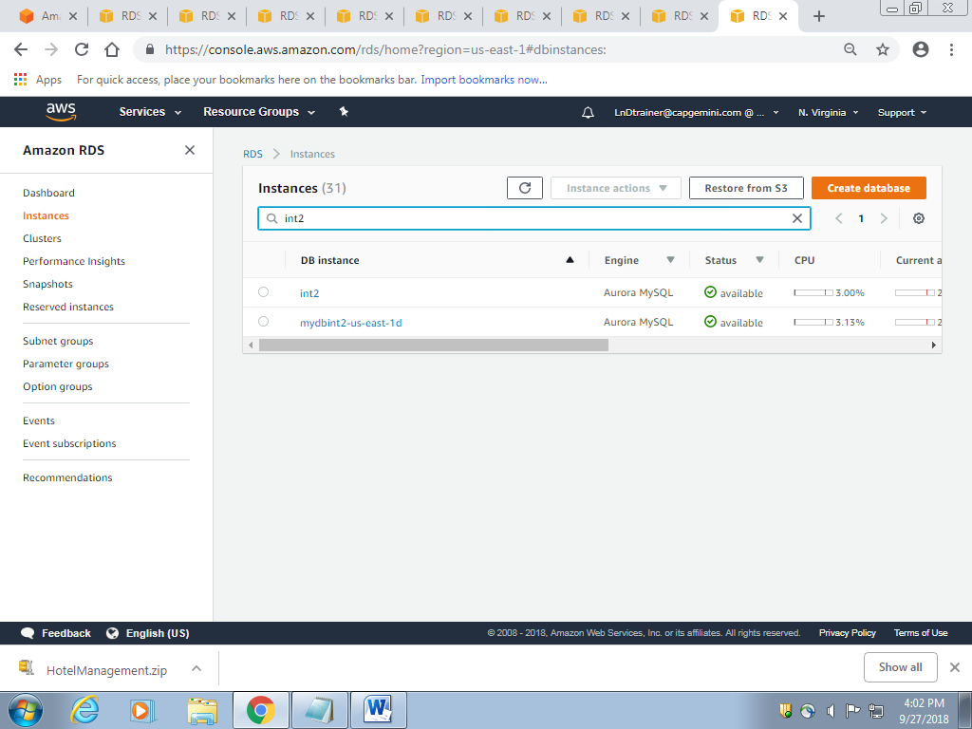

13] Once instance status is available click on **second db instance** as shown below

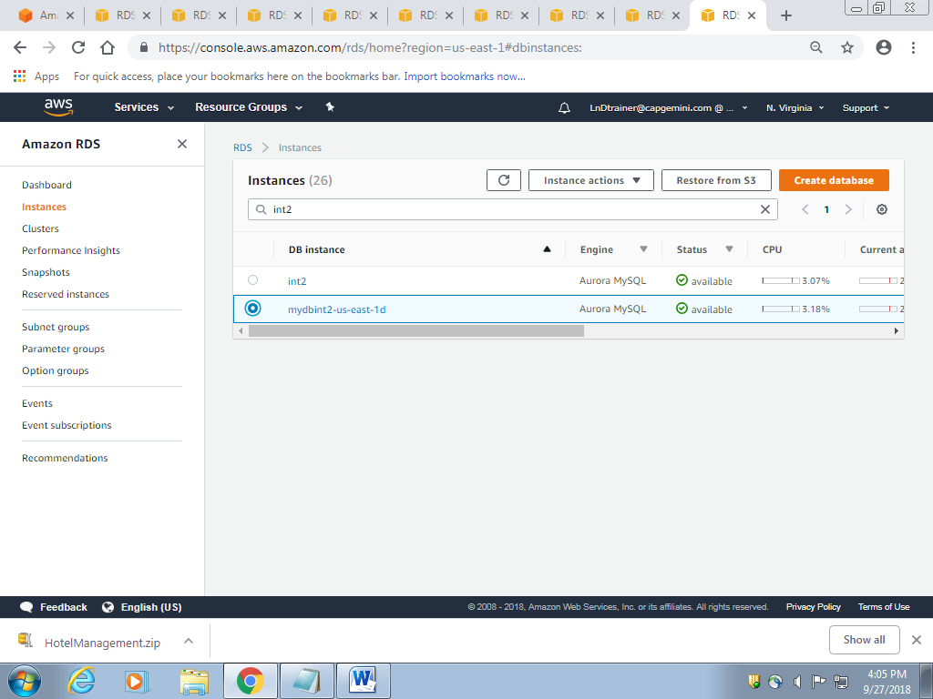

14] Scroll down to Connect ---> Security Groups -->click on second link (**CIDR/IP - Outbound)**

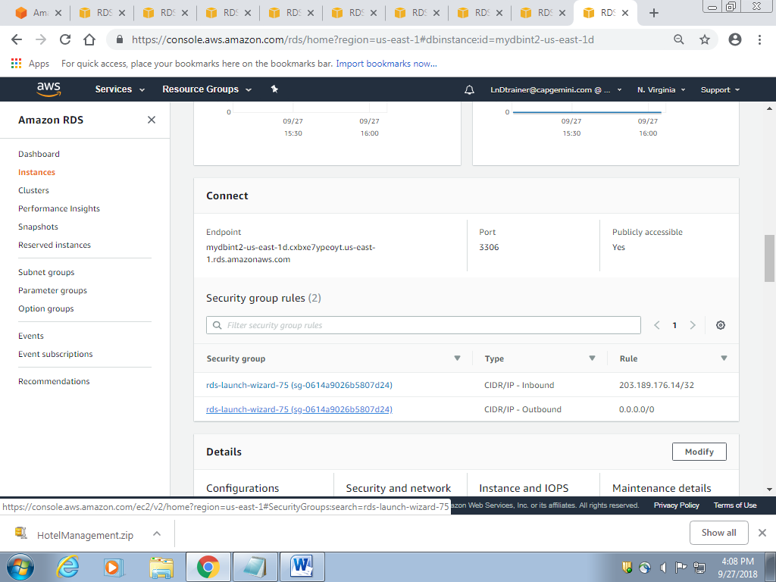

15] Go to inbound-->edit--> Change source from custom to anywhere and click save

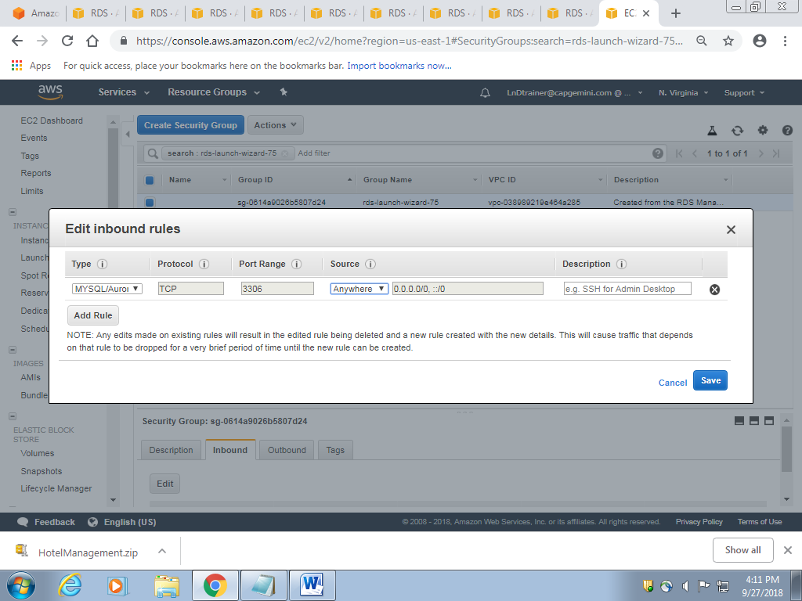

16] Go to outbound-->edit--> Change source from custom to anywhere and click save

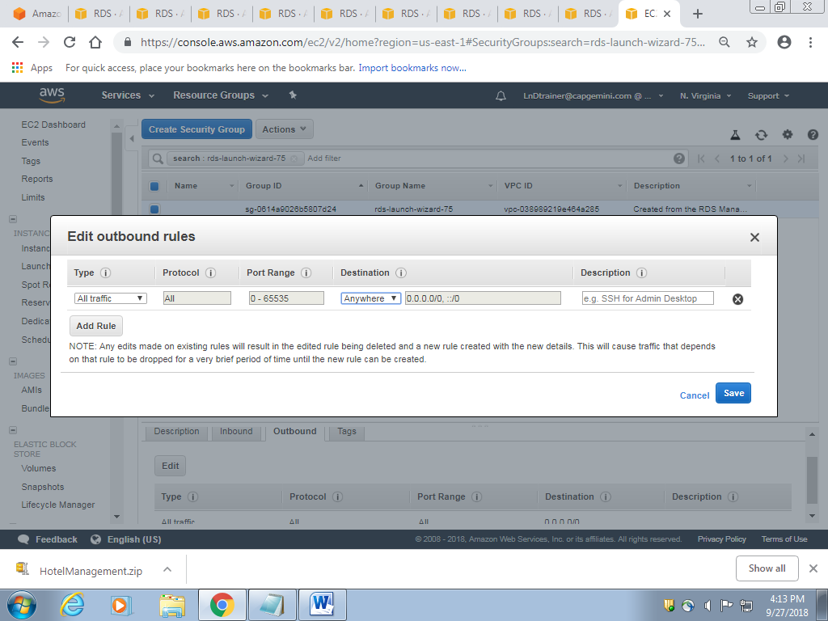

17] Go to Services--->RDS--->find your db instance--->click on second link--->search for end point

Copy the End point link.

18]Open Eclipse--->Windows--->open perspective-->other-->Database Development.

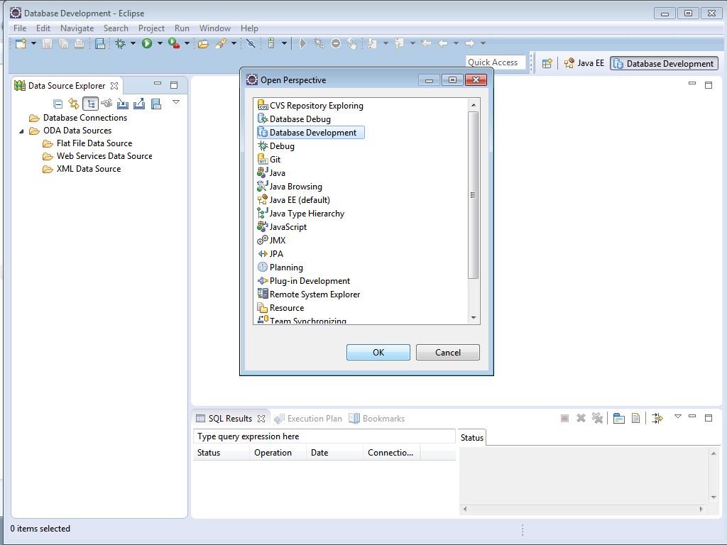

19] Package Explorer-->Database Development(right-click)--->New-->MySQL-->Add jar file.

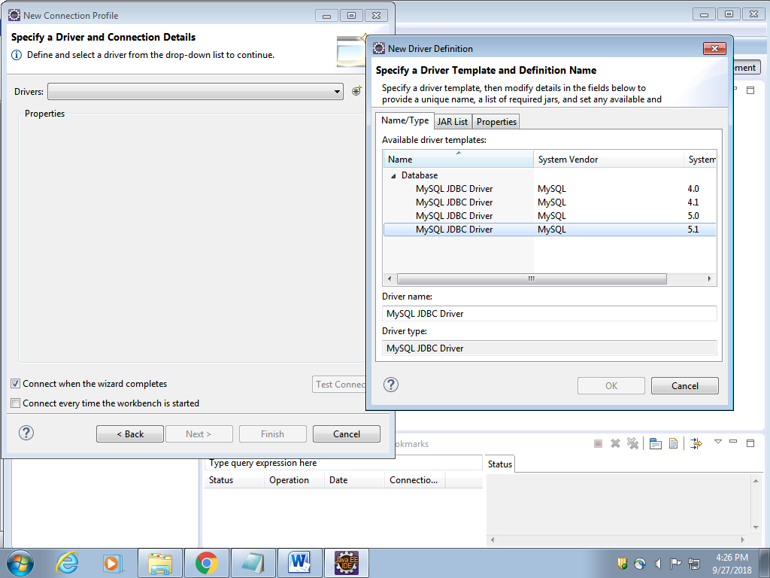

20]Enter details as shown

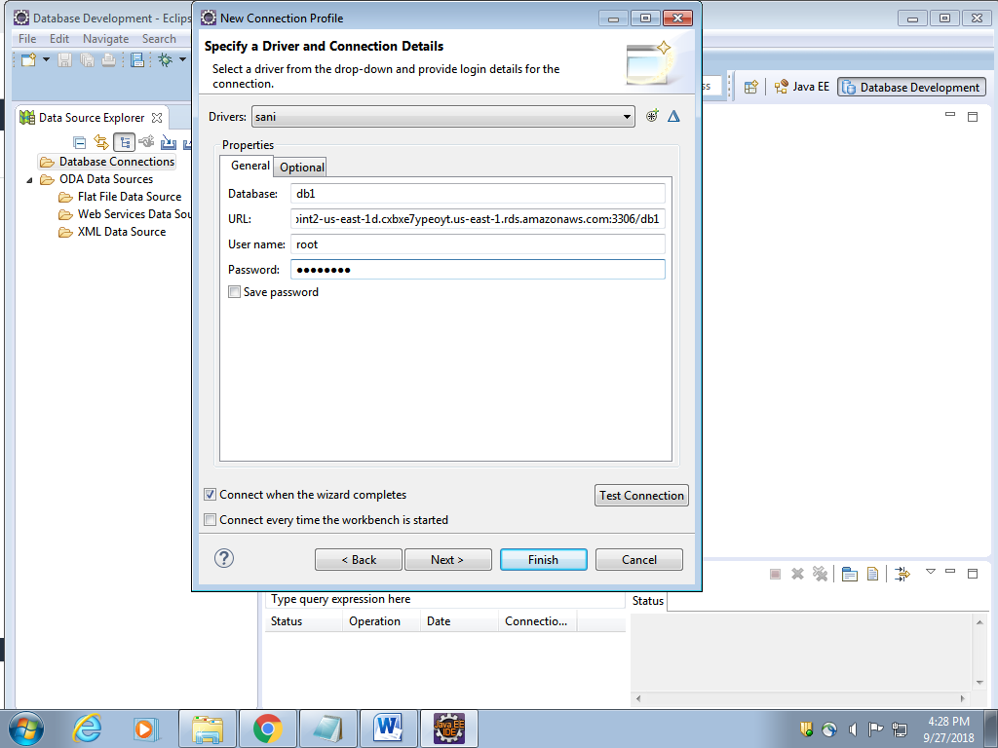

21] Test connection and finish.